DEDUCE Dose Escalation Recommendations
Trial Design: CRM
Software: DEDUCE app version 1.0 available here
Report Date and Time: 2021-11-09 01:13:18

Observed Toxicity Data:
Patient ID | Dose  level | DLT Observed | Include in model
C1 | 2 | FALSE | TRUE
C1 | 2 | FALSE | TRUE
C2 | 2 | FALSE | TRUE
C4 | 2 | TRUE | TRUE
C5 | 3 | FALSE | TRUE
C6 | 3 | FALSE | TRUE
C7 | 3 | TRUE | TRUE

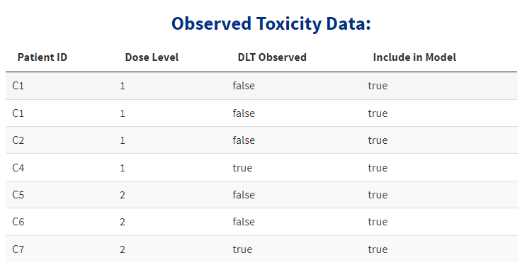

Toxicity Probability Results:
(90 Percent Probability Interval)
Dose level | Prior Prob. Of DLT | # Patients | # DLTs | Posterior Prob. of DLT | Lower Limit | Upper Limit
-1 | 0.05 | 0 | 0 | 0.136 | 0.0159 | 0.384
1 | 0.12 | 4 | 1 | 0.244 | 0.0534 | 0.507
2 | 0.20 | 3 | 1 | 0.343 | 0.1080 | 0.598
3 | 0.30 | 0 | 0 | 0.449 | 0.1890 | 0.680
Next Recommended Dose Level: 1
Recommendation is Based on a Target Toxicity Probability of 0.2

Additional Details:
Current Dose Level: 1
Cohort Size: 3
Number of Slots Remaining at Current Dose Level: 2

Dose Escalation Rules:
- No dose skipping upon dose escalation
- Intra-cohort dose de-escalation is allowed
- Intra-cohort dose escalation is not allowed

Estimation Details:
Empiric Dose-Toxicity Model: $p=dose^{exp(beta)}$
dose = 0.05, 0.12, 0.2, 0.3
Normal Prior on Beta with Mean 0 and Variance 1.34
Posterior Mean of Beta: -0.408091
Posterior Variance of Beta: 0.1978329

